**Assignment No:-55**

Name:-Suryawanshi Sangramsingh Sambhaji

Batch: - Delta - DCA (Java) 2024 Date:-30/7/2024

**Q.1 Implement the Comparable interface for a Person class that compares instances based on their age.**

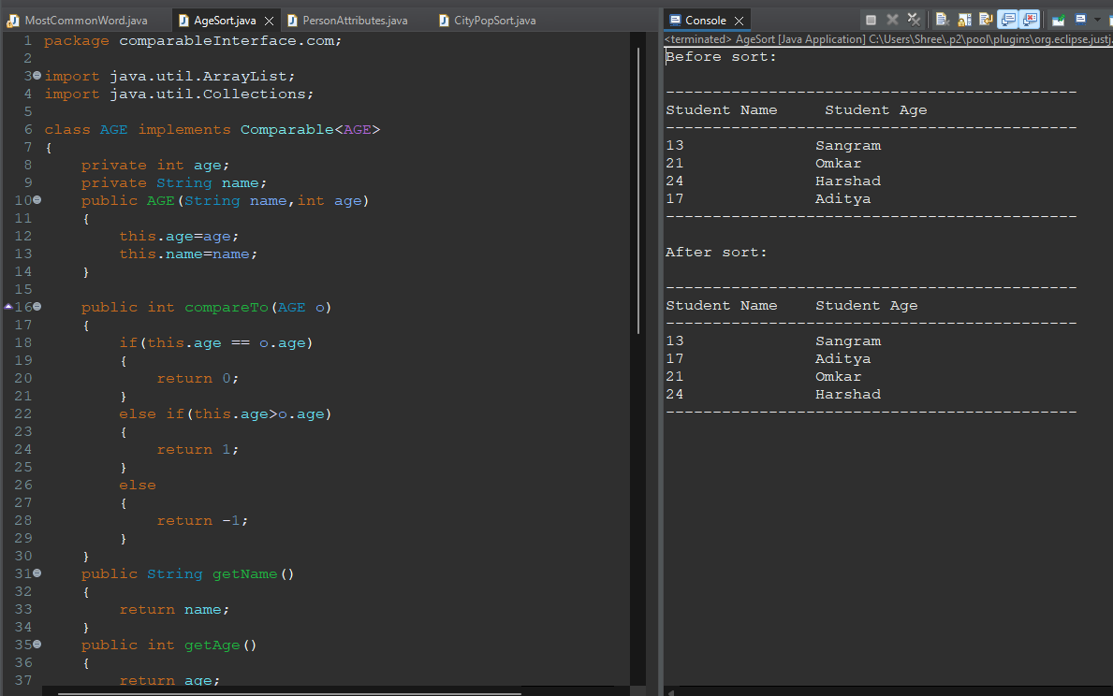

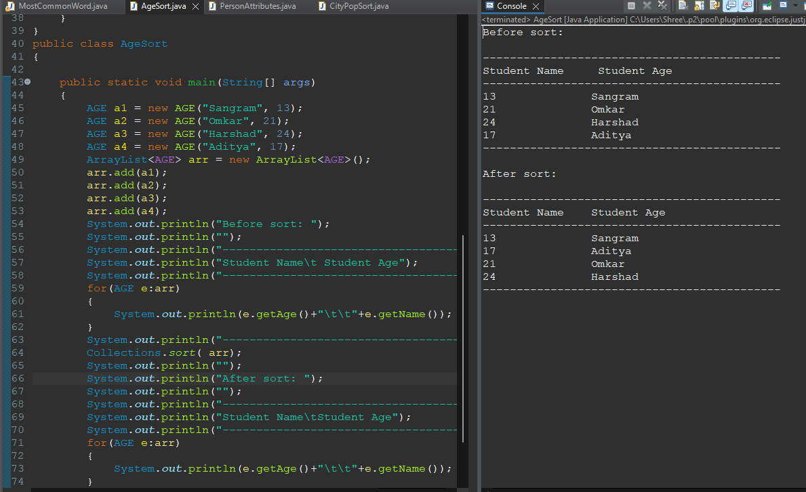

**Q.2 Create a class Book that implements Comparable and compares books based on their titles.**

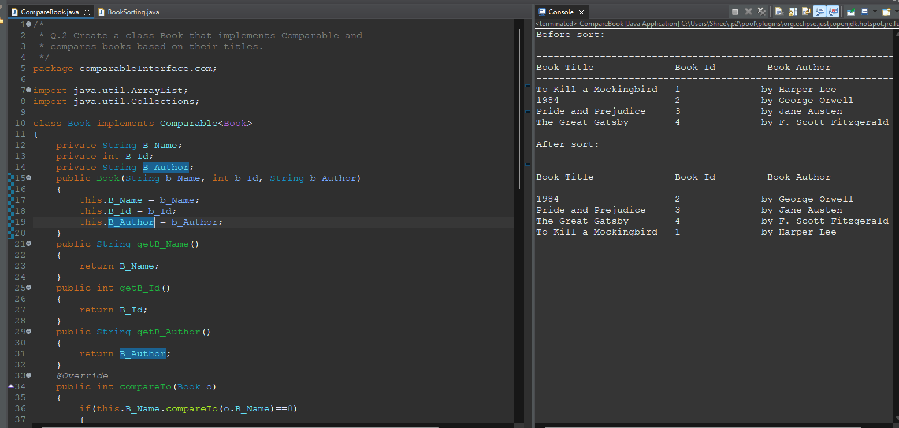

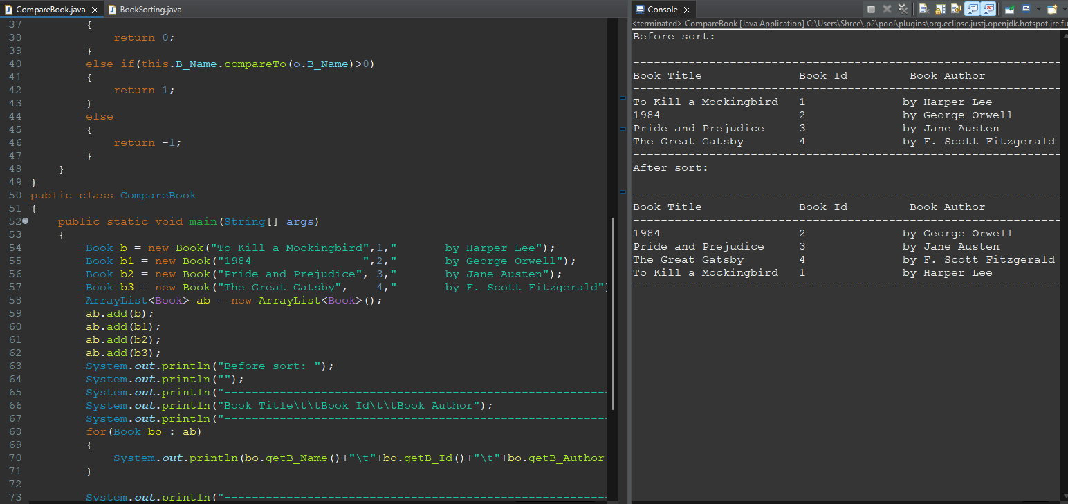

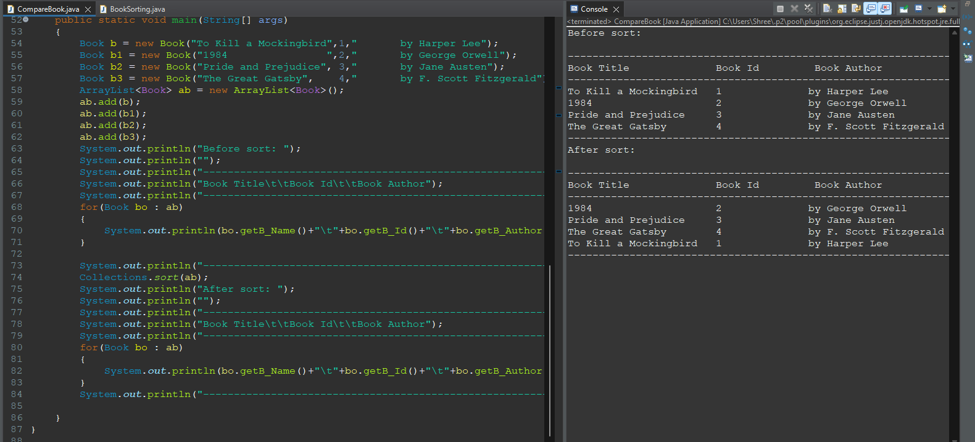

**Q.3 Implement Comparable for a Product class considering their prices.**

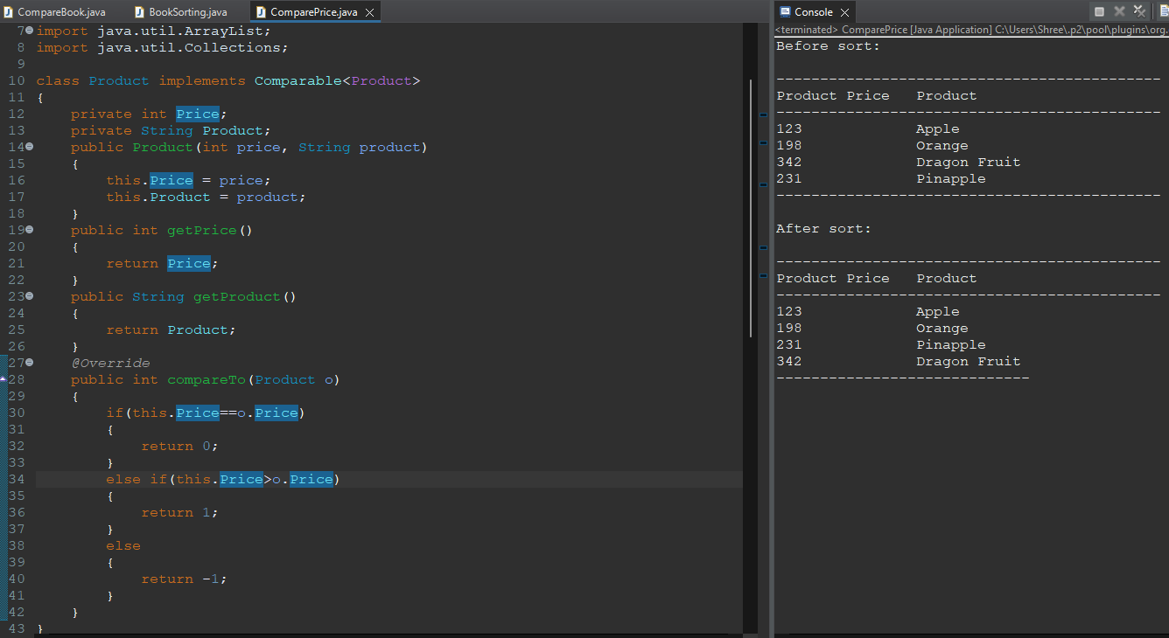

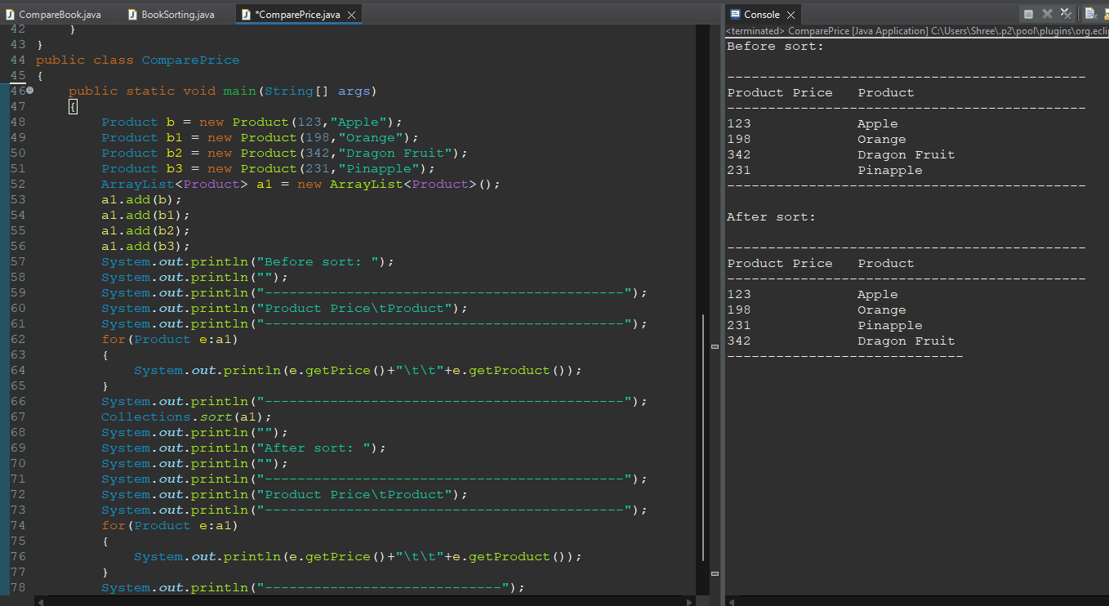

**Q.4 Make a Student class Comparable based on their GPA.**

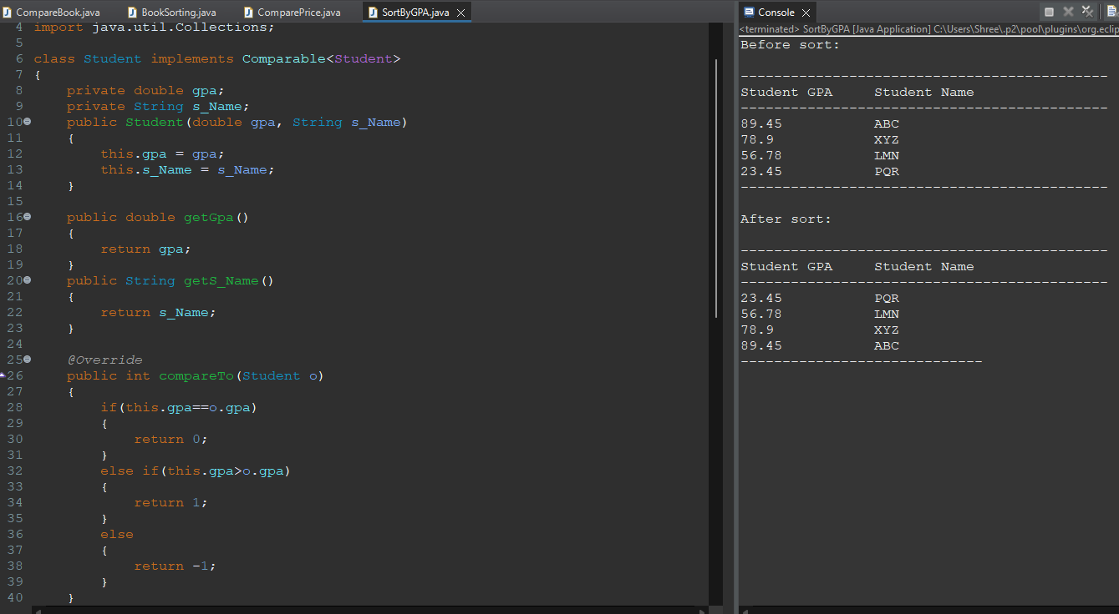

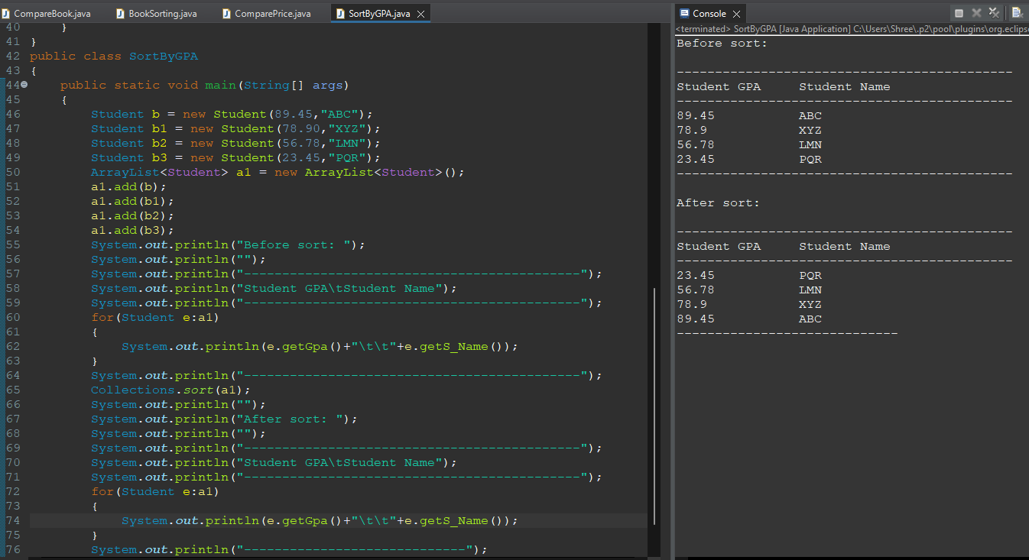

**Q.5 Create a Song class that implements Comparable for sorting songs based on their play durations.**

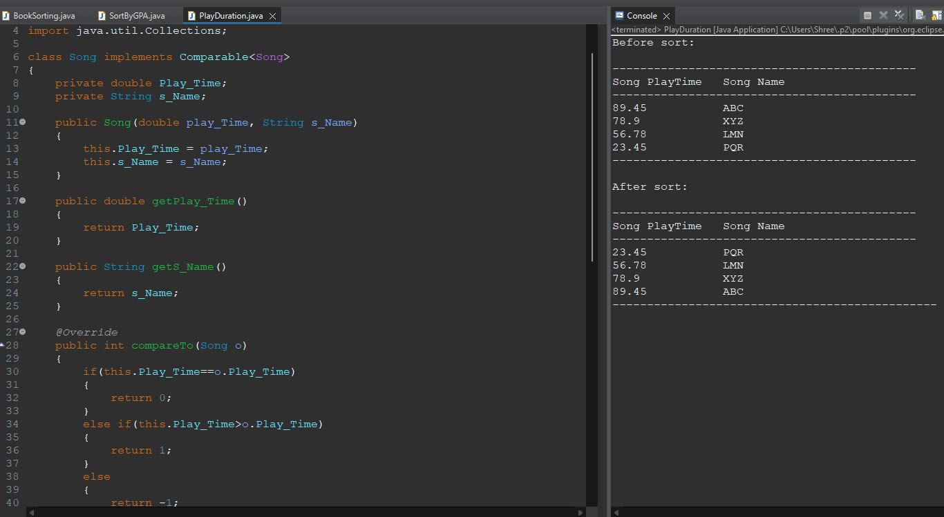

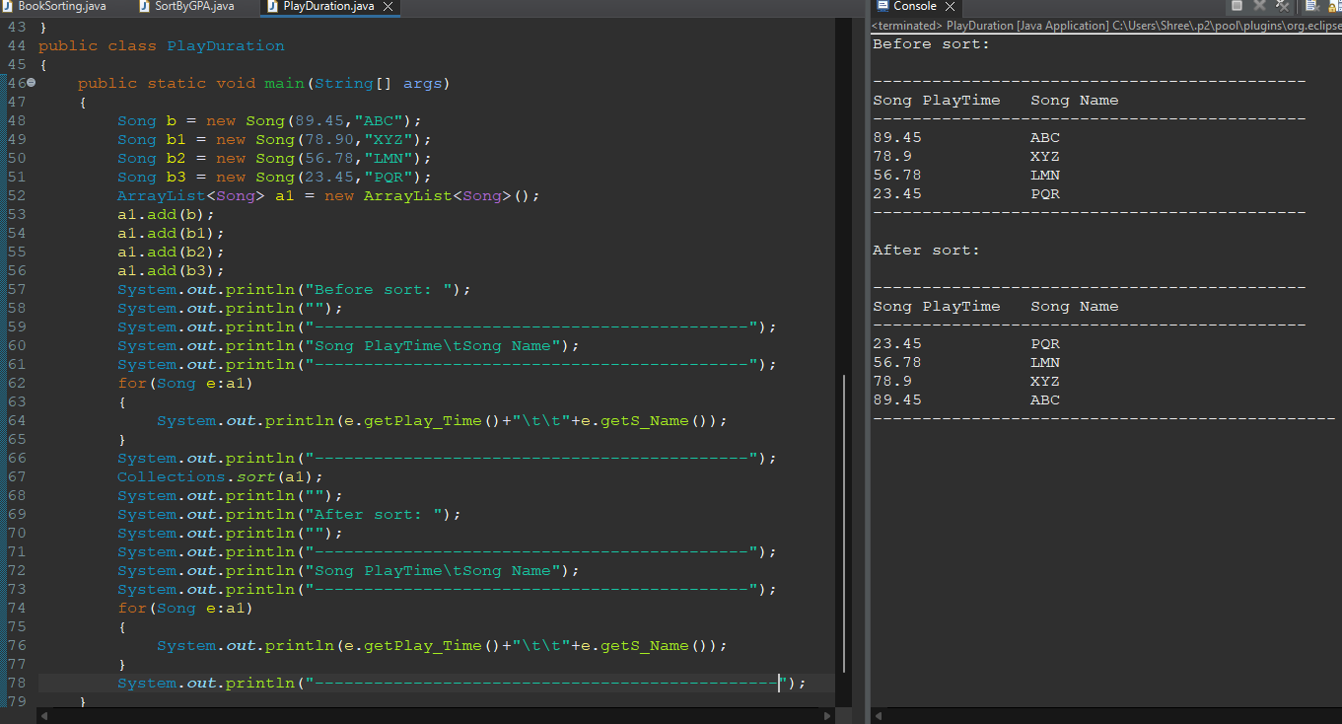

**Q.6 Implement the Comparable interface for a Person class that compares instances based on their height.**

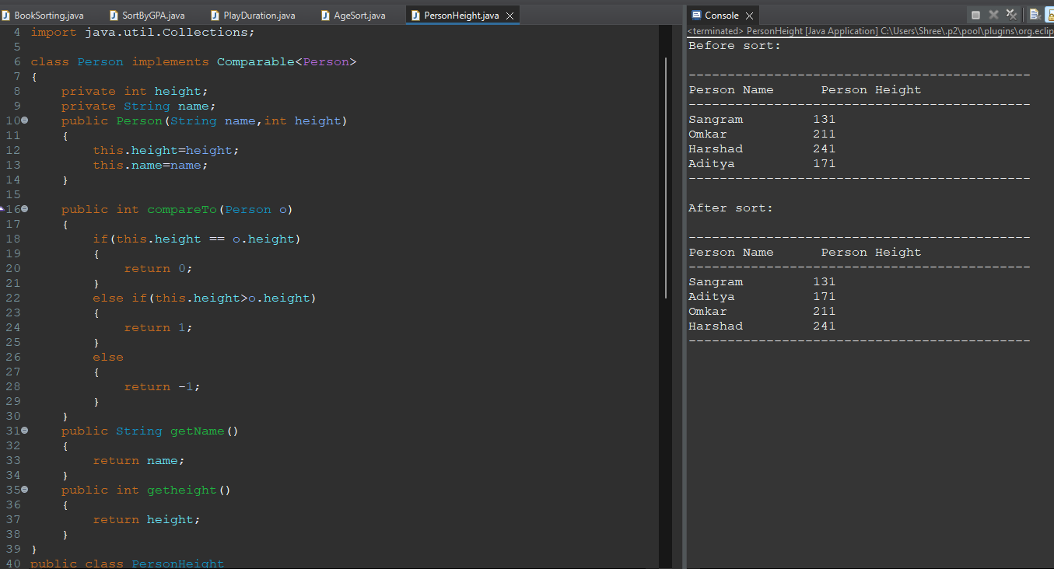

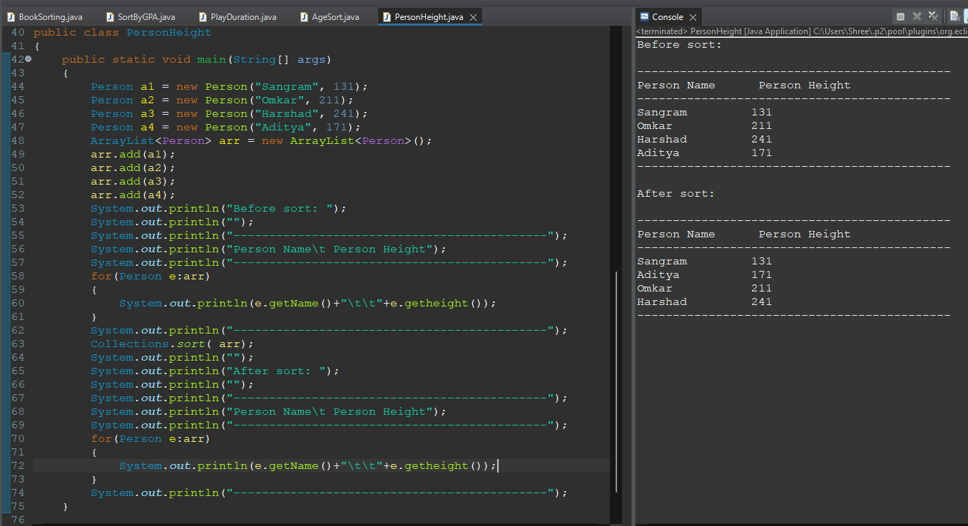

**Q.7 Create a Car class that implements Comparable and compares cars based on their top speed.**

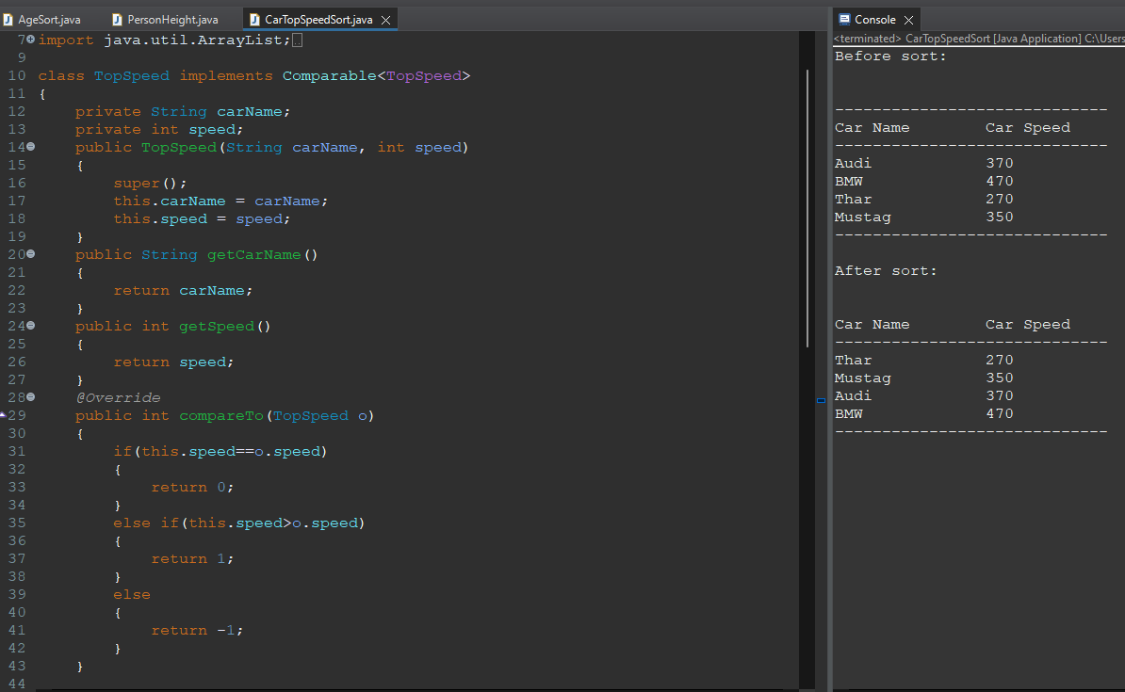

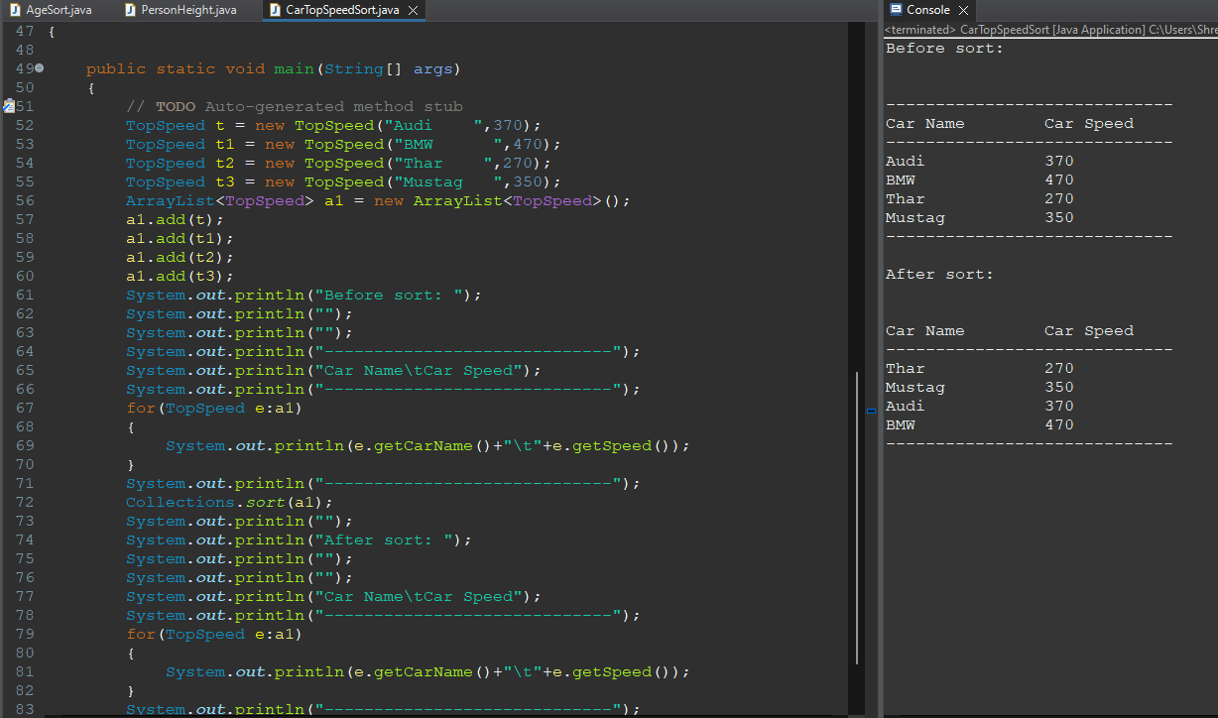

**Q.8 Implement Comparable for a Country class considering their population.**

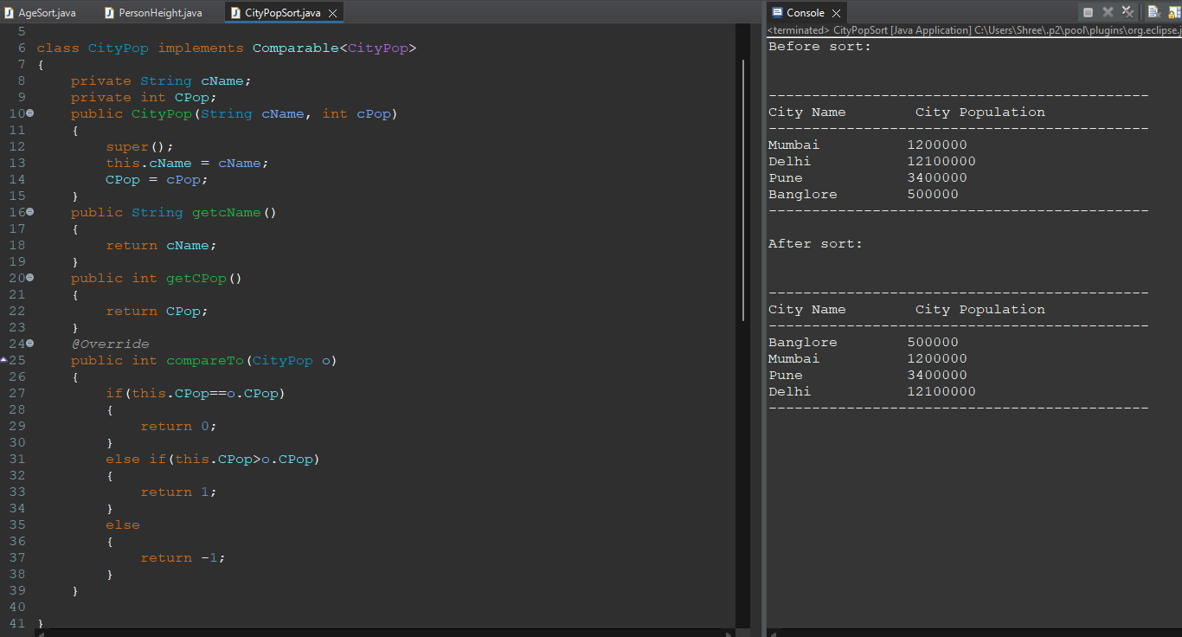

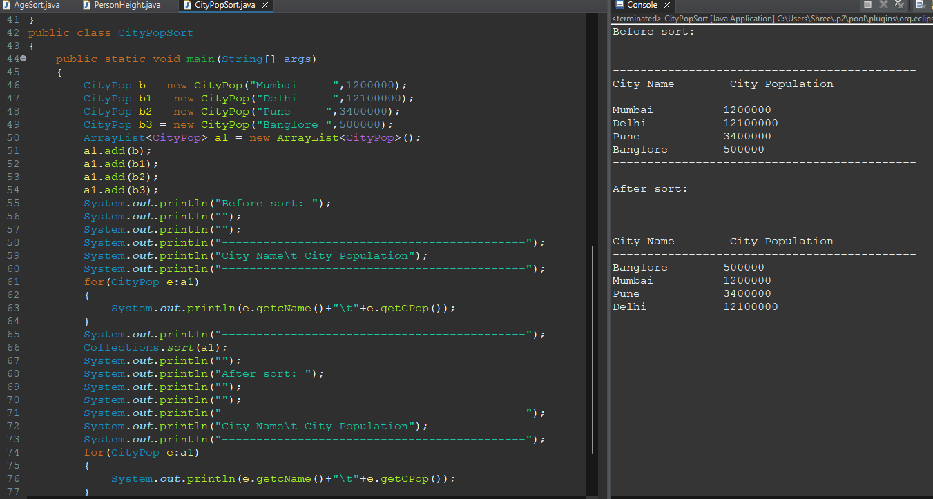

**Q.9 Make a Team class Comparable based on the number of games won.**

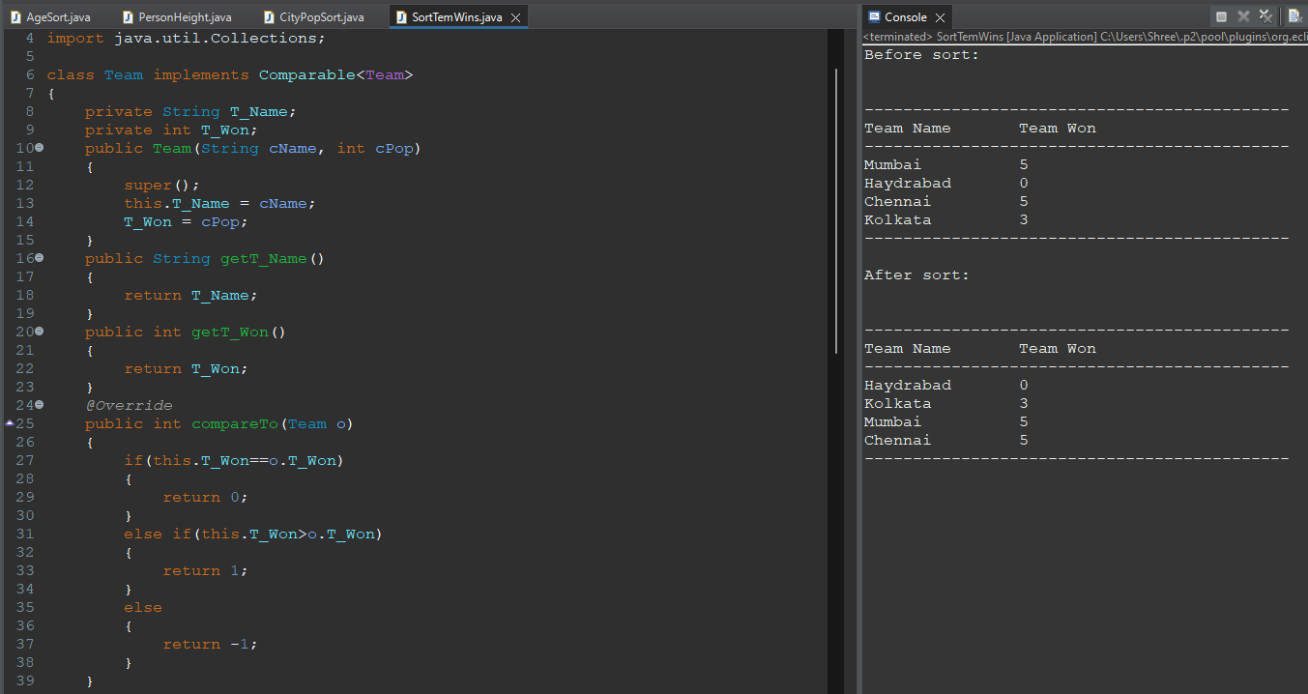

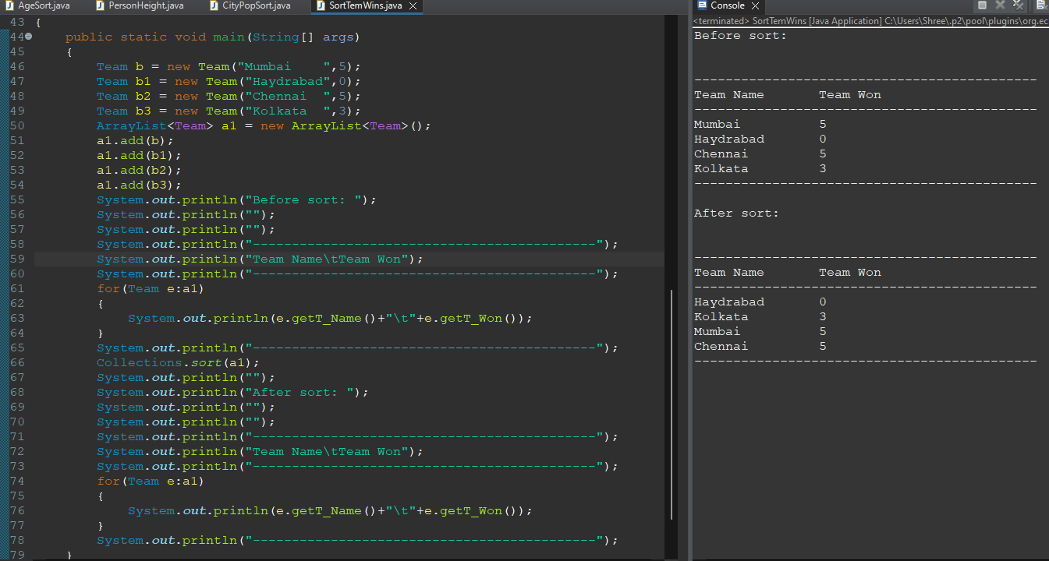

**Q.10 Design a City class that implements Comparable for sorting cities based on their population density.**

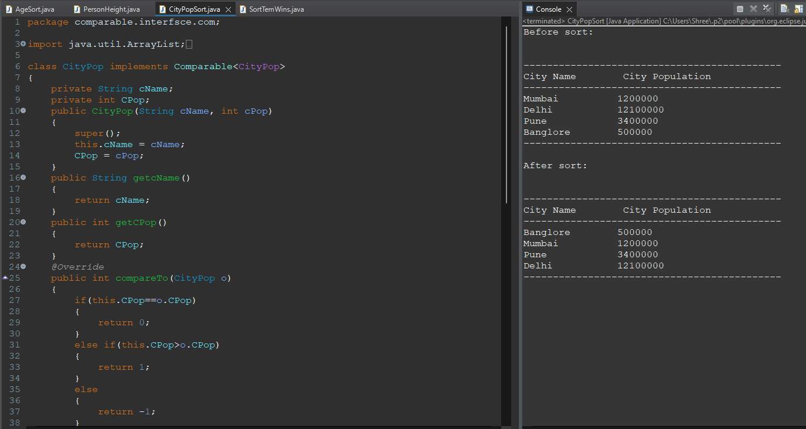

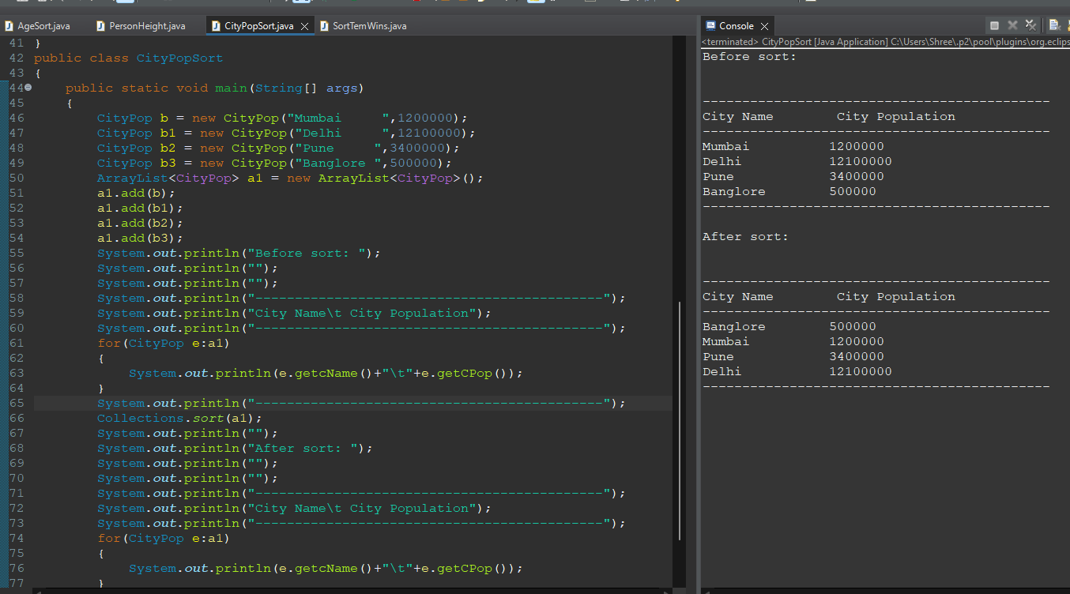

**Comparator:**

**Q.11 Write a Comparator to sort Employee objects by their salary in descending order.**

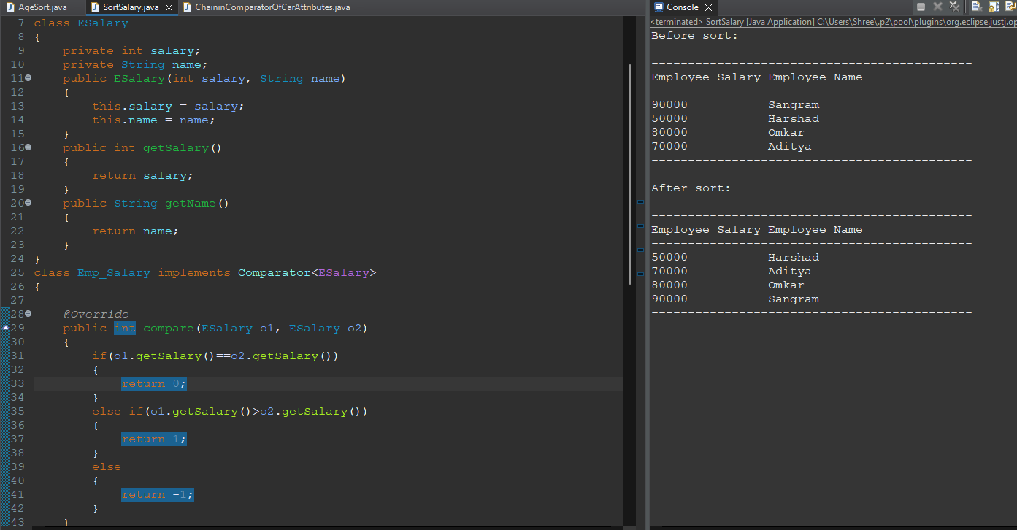

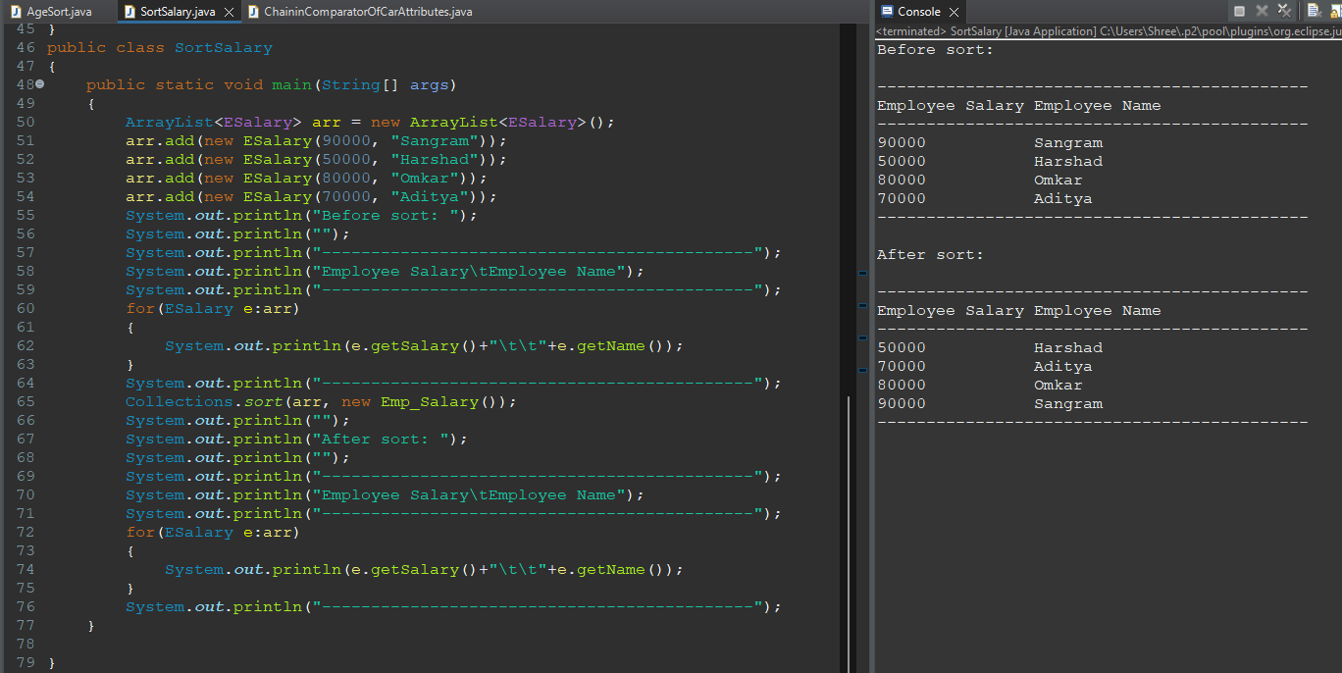

**Q.12 Create a Movie class and implement a Comparator to sort movies by release year.**

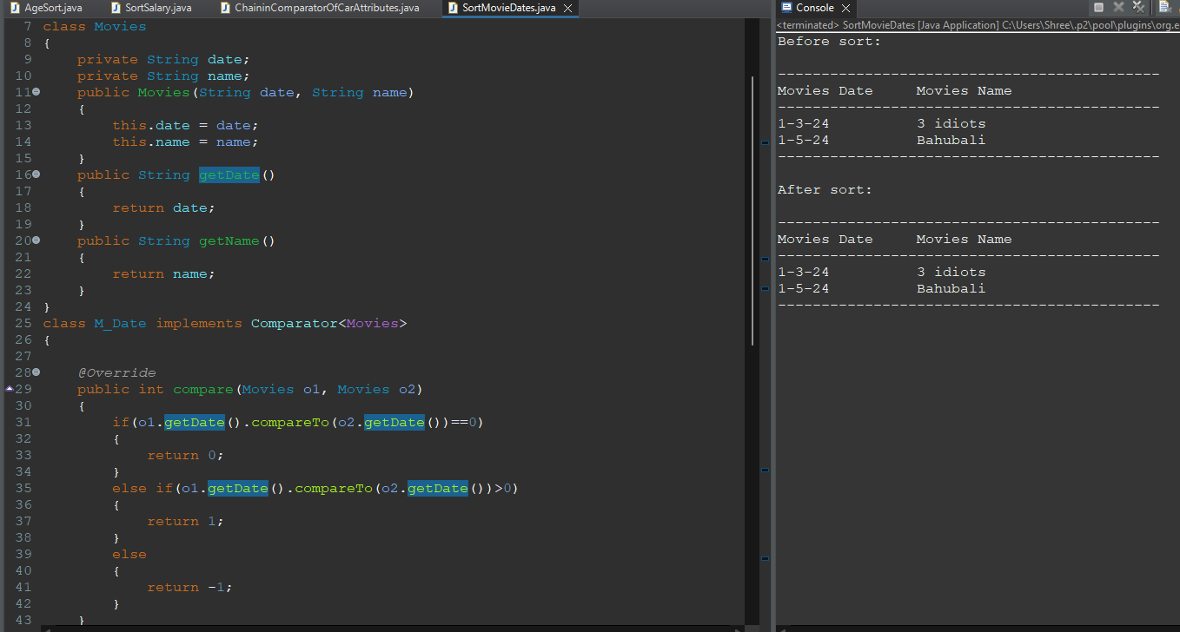

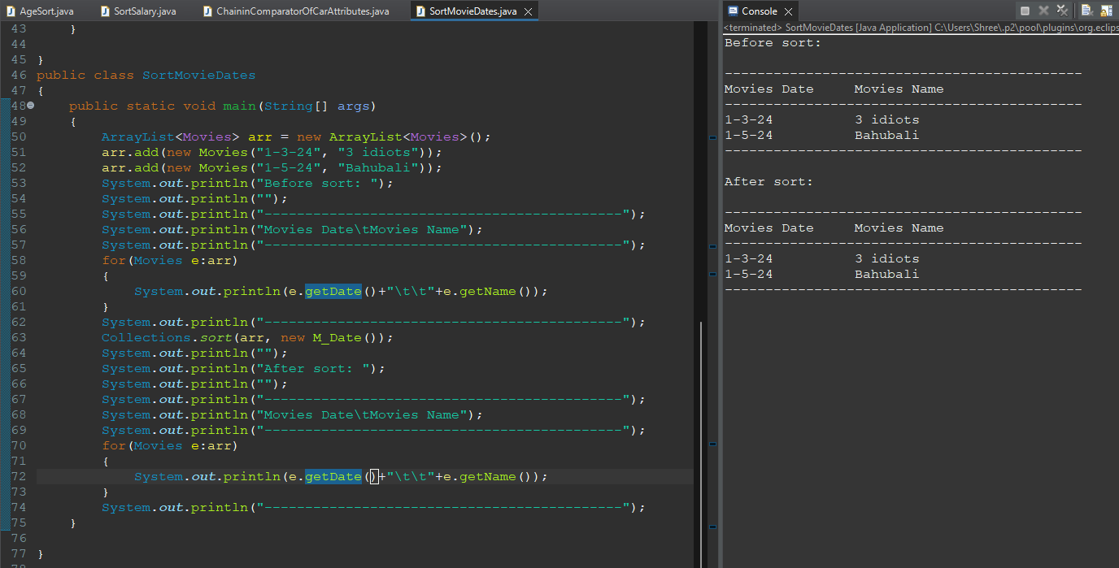

**Q.13 Implement a Comparator to sort Product objects by name in ascending order.**

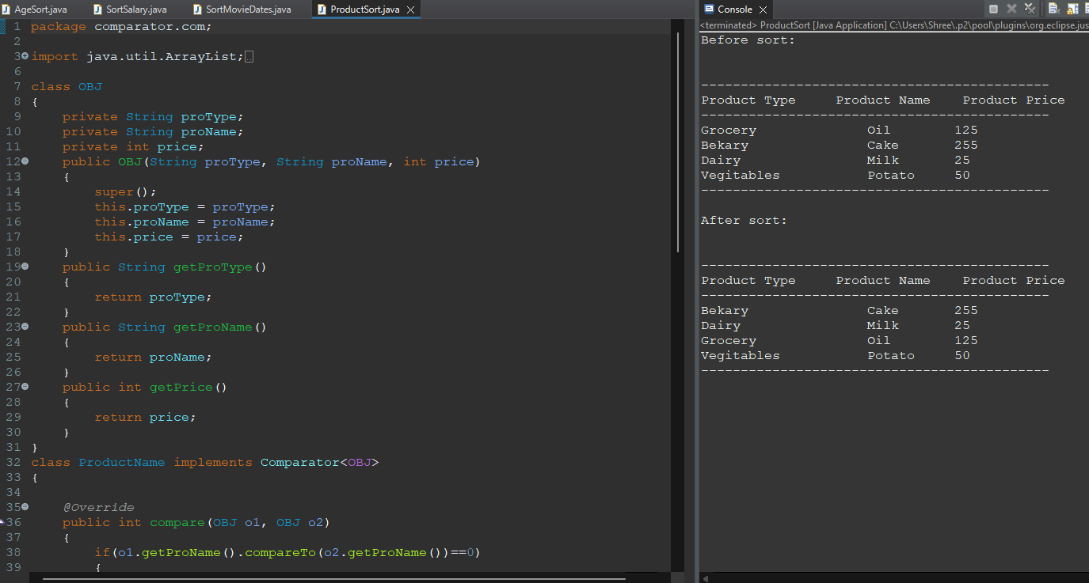

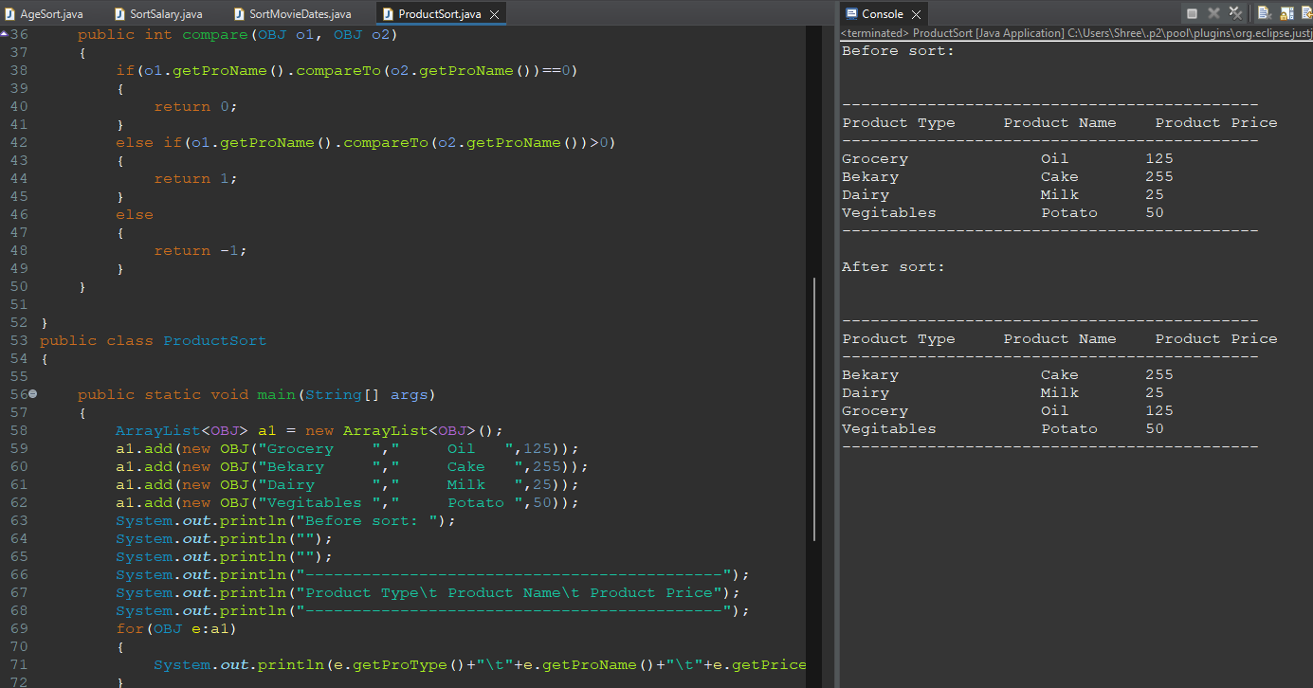 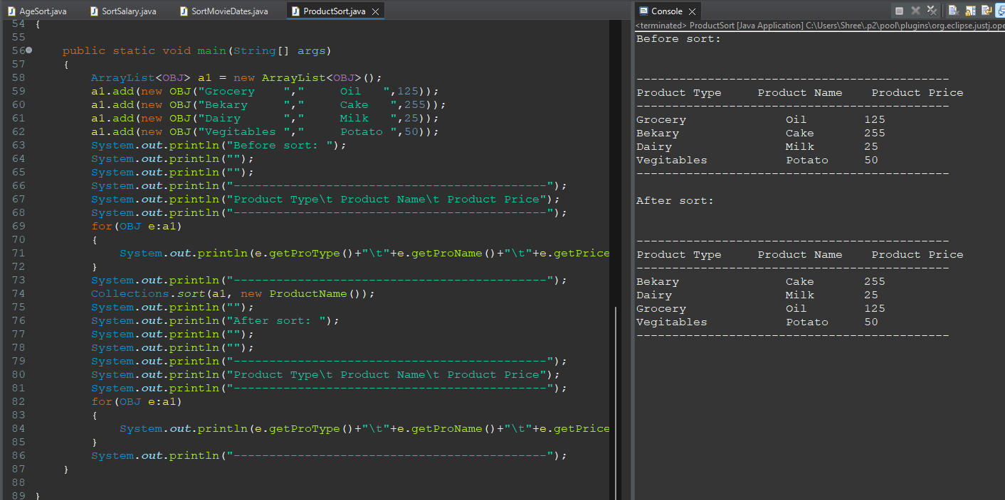

**Q. 14 Write a Comparator to sort a list of Student objects by their age.**

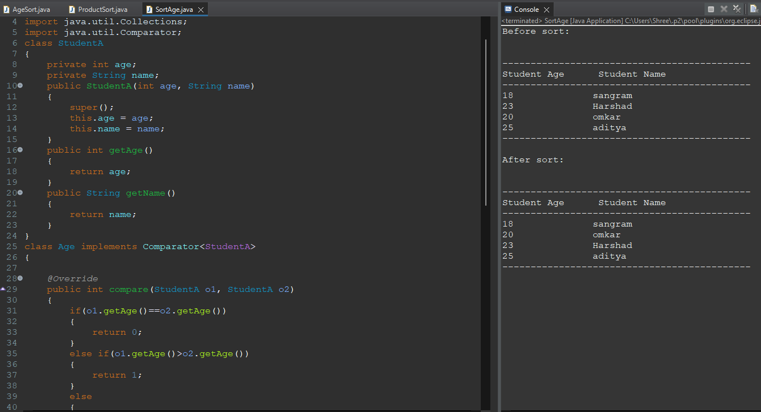 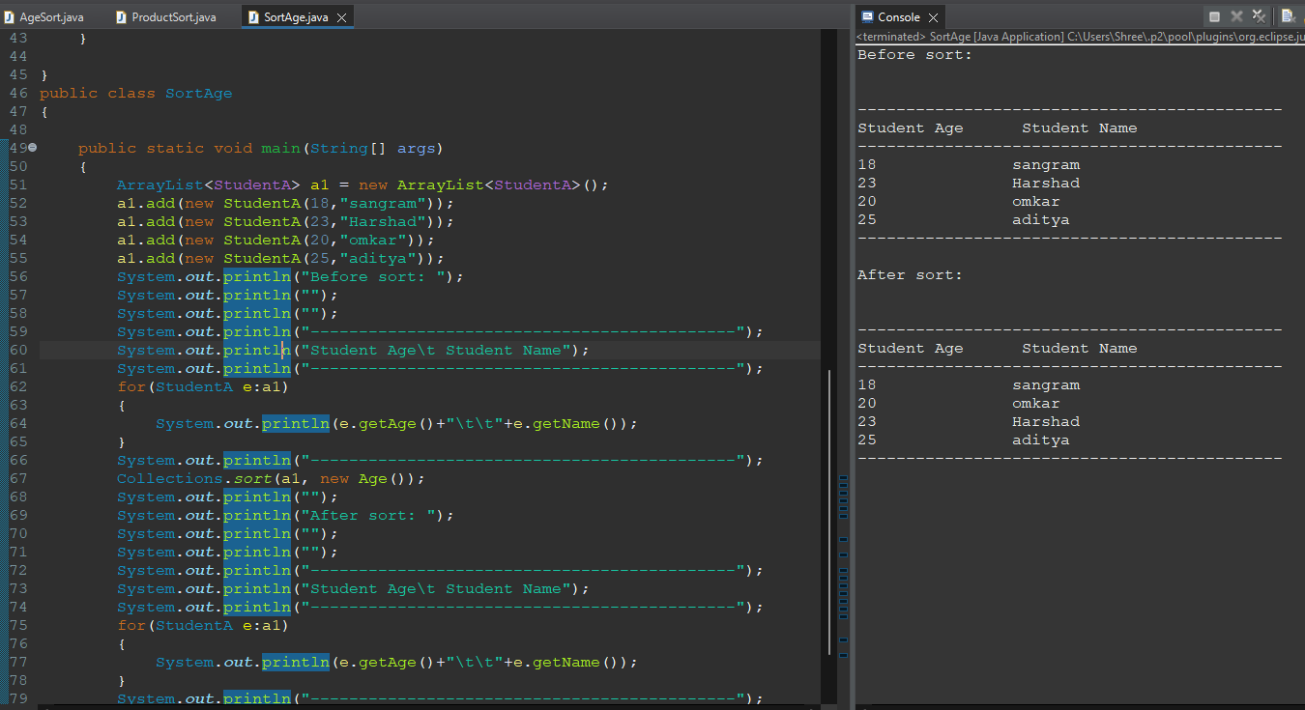

**Q.15 Create a Person class and implement a Comparator to sort instances by their last names.**

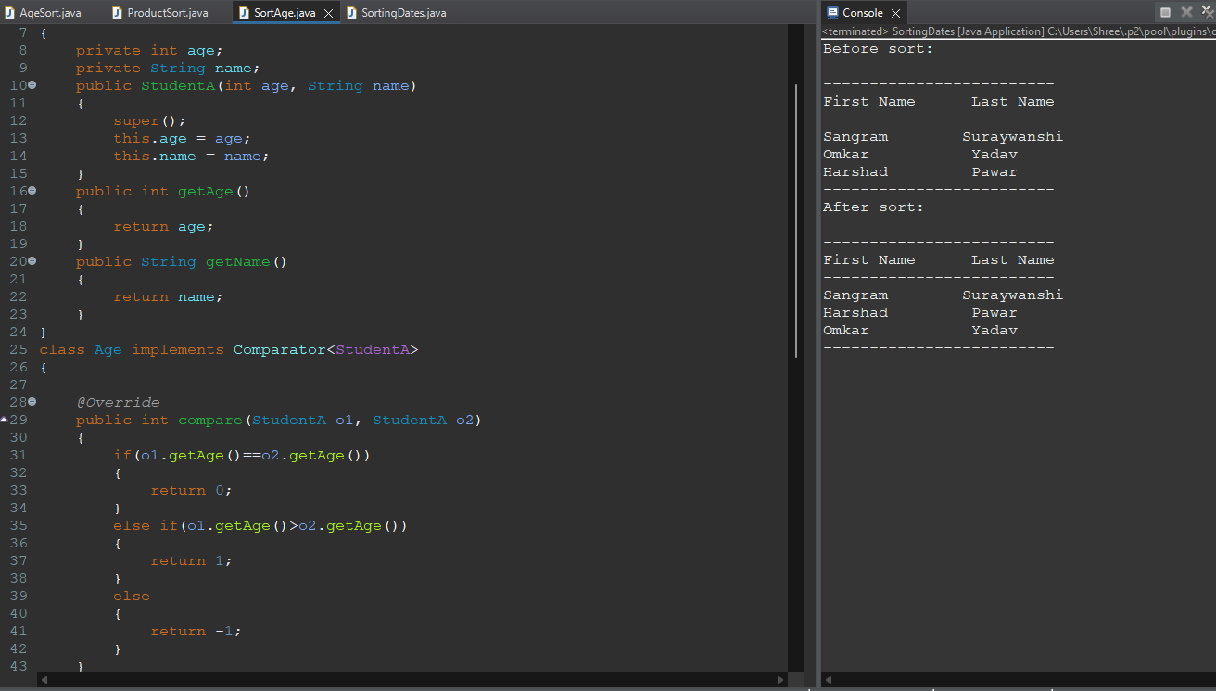

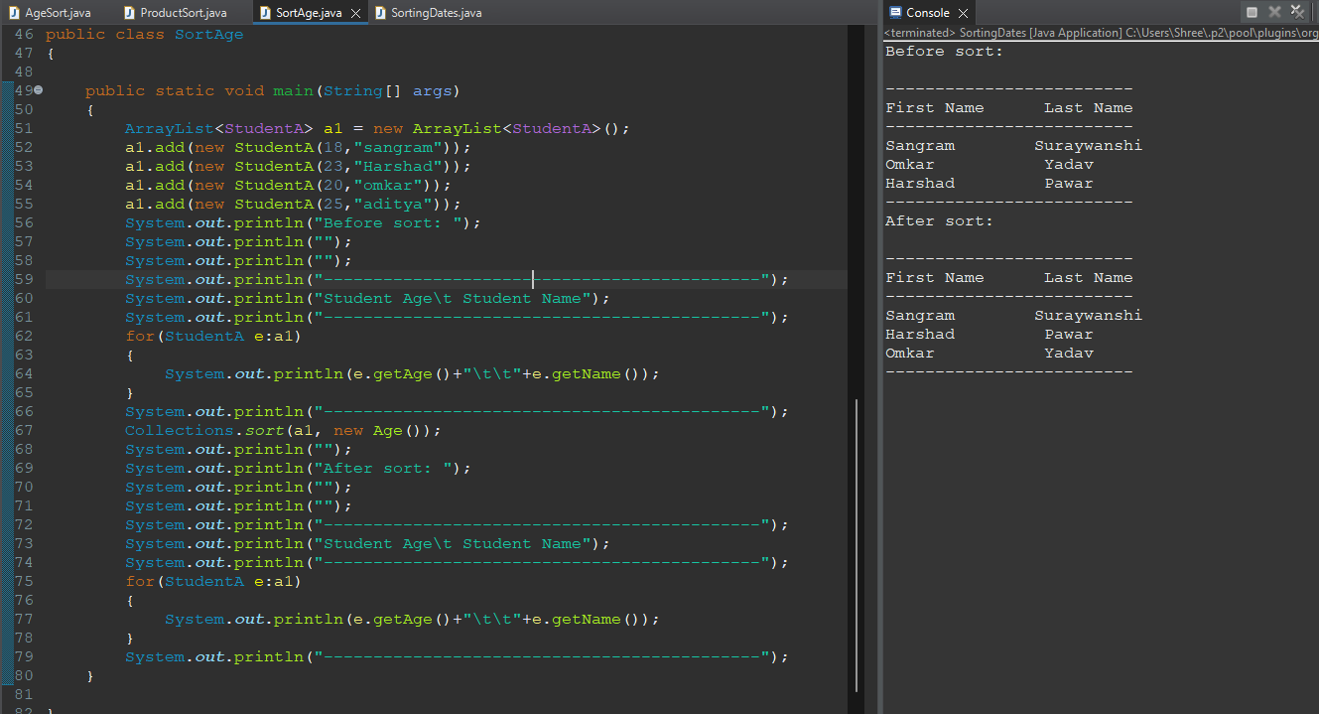

**Q.16 Write a Comparator to sort Student objects by their last name, and if last names are the same, sort by first name.**

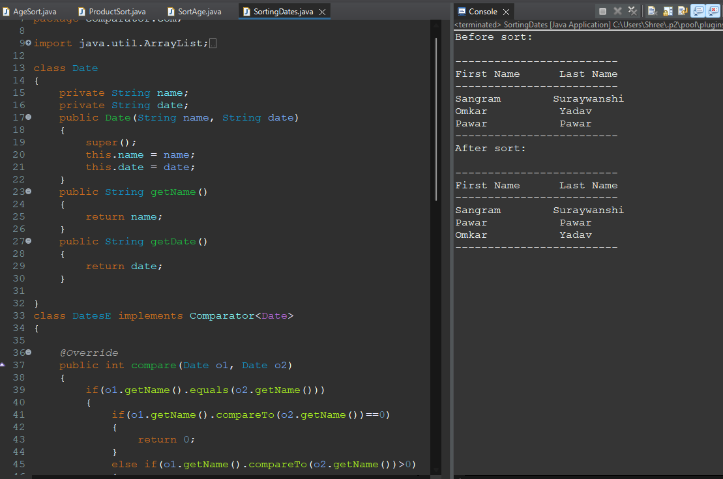

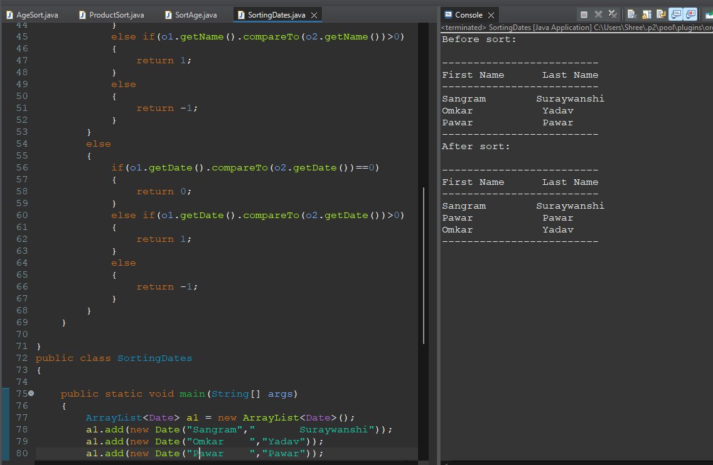

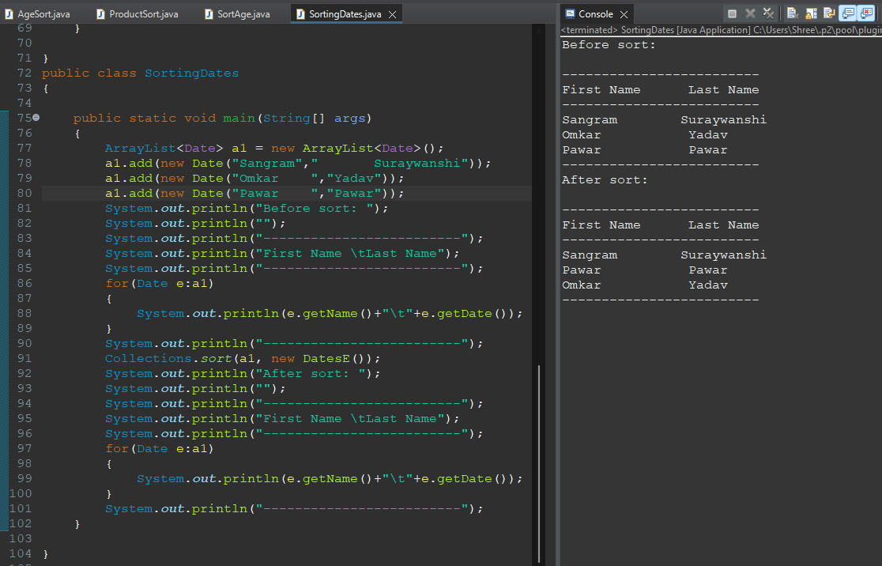

**Q.17 Create a Phone class and implement a Comparator to sort phones by battery capacity.**

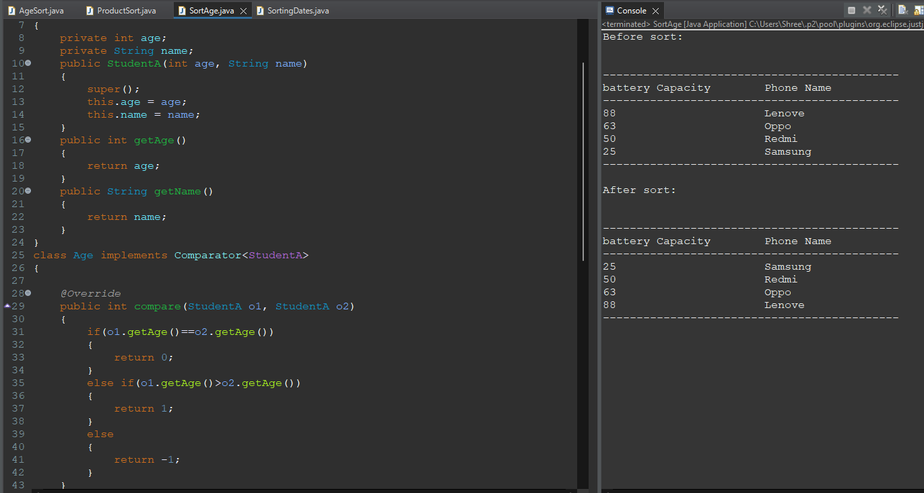

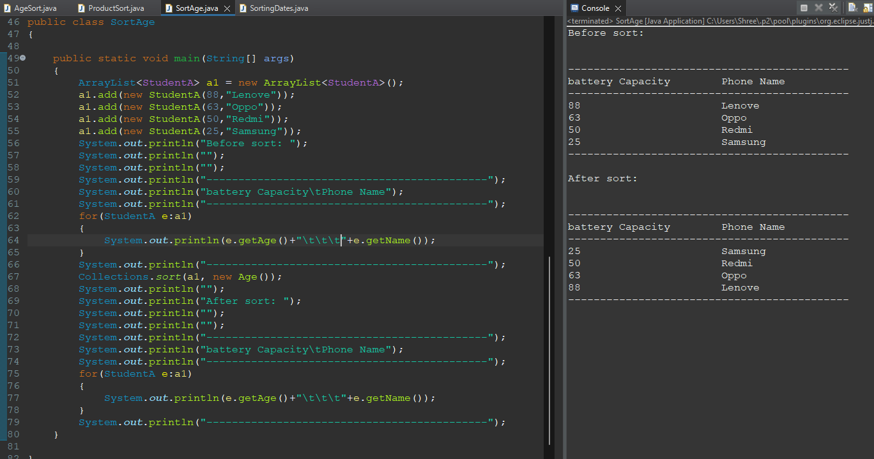

**Q.18 Implement a Comparator to sort a list of Order objects by order date.**

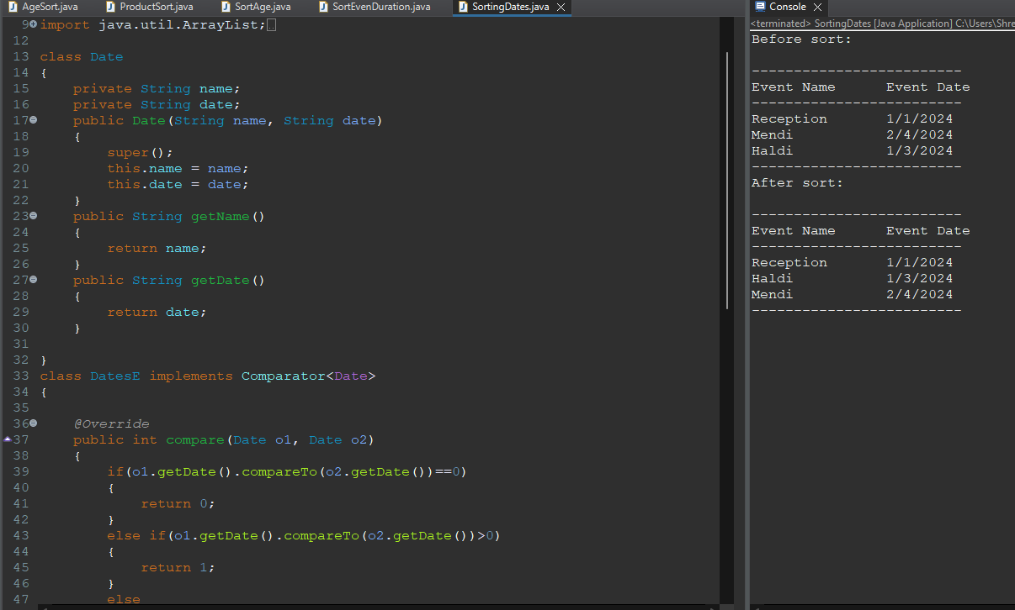

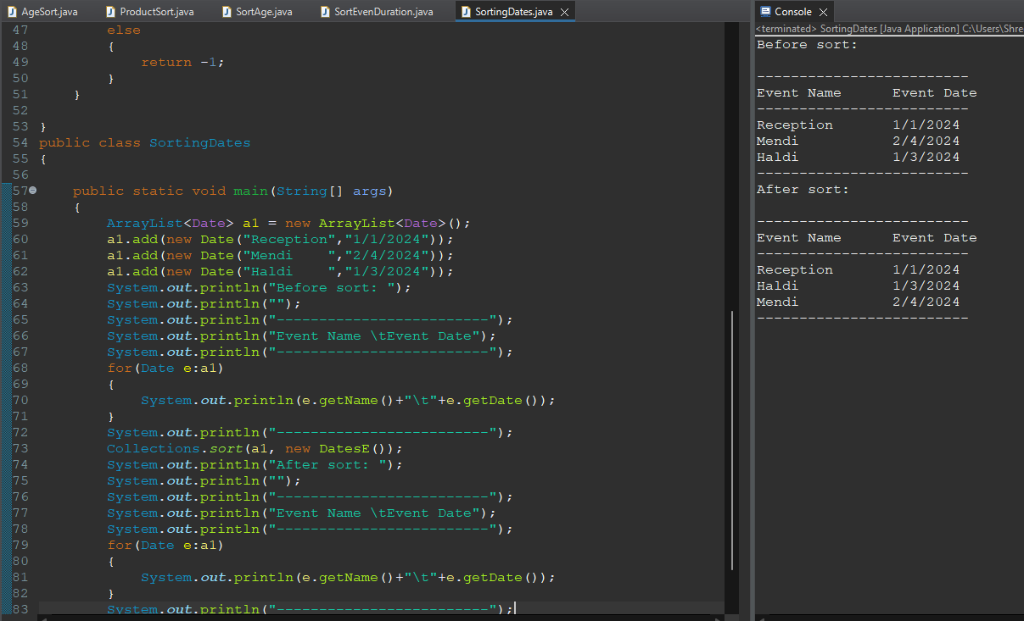

**Q.19 Write a Comparator to sort Song objects by artist name in ascending order.**

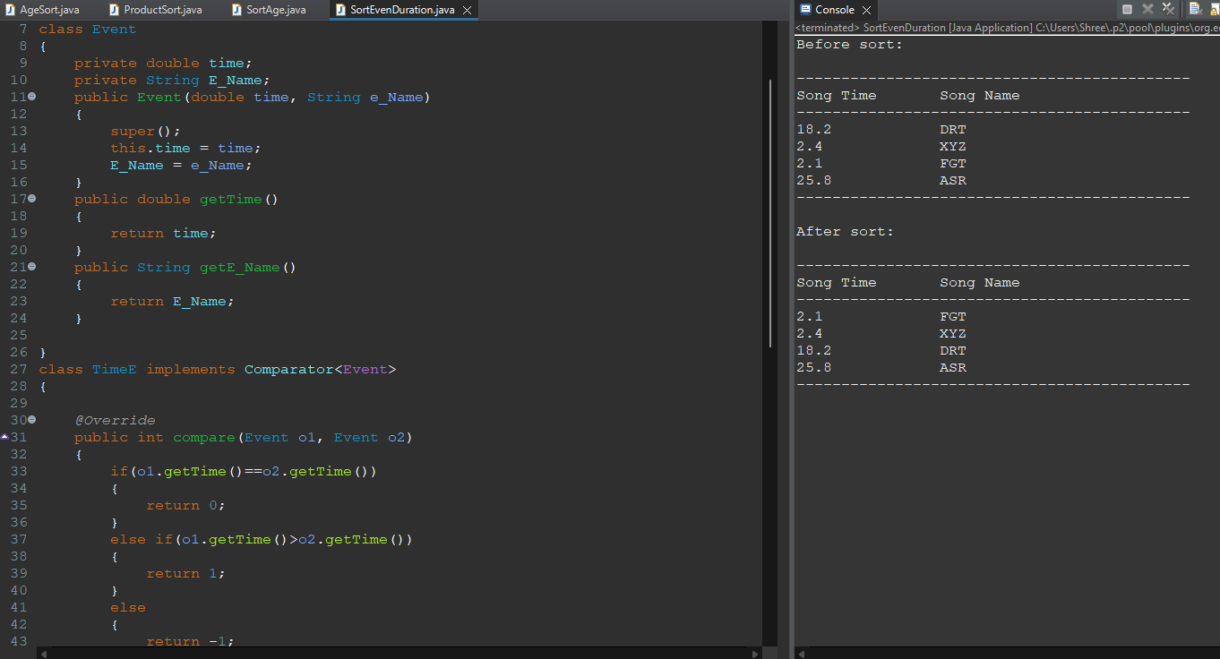

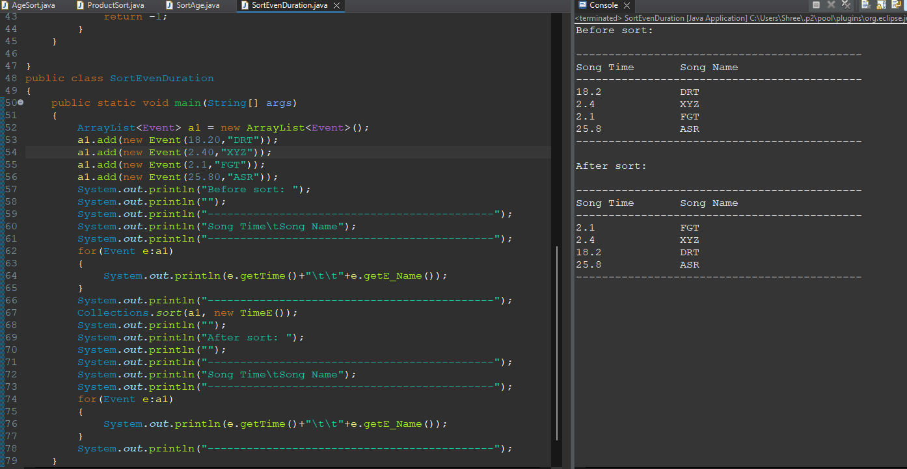

**Q.20 Create a Event class and implement a Comparator to sort events by duration**

